**When The User Downloads the App :**

The Splash Screen Appears to them For Only 2 Seconds

After Splash Screen, The Login Page will appear

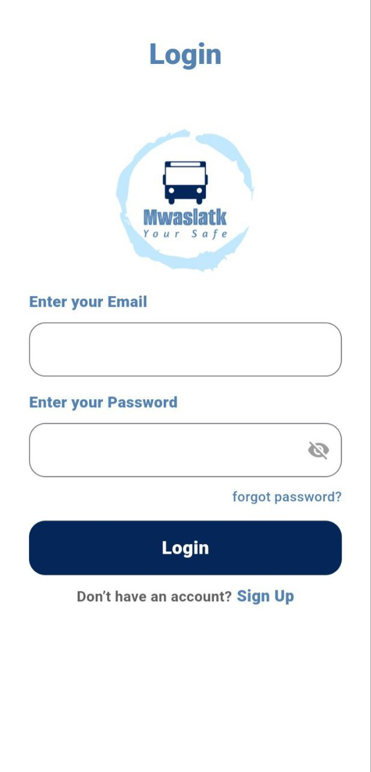

The User Can Click On Sign Up to make an account

through the Register Screen

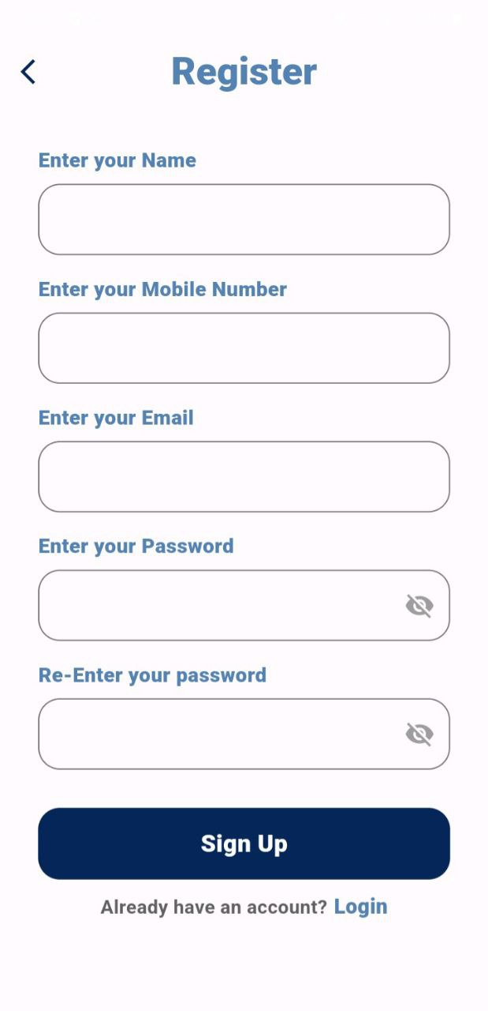Register Screen

The User must fill all this data

If The User writes anything against the term or

does not fill in a field, It will show them a message

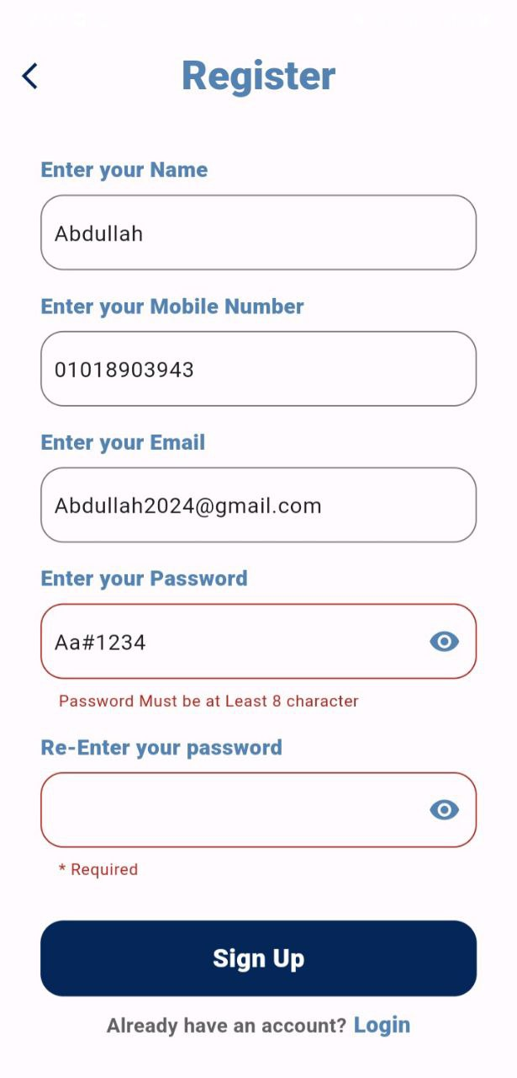 like this.

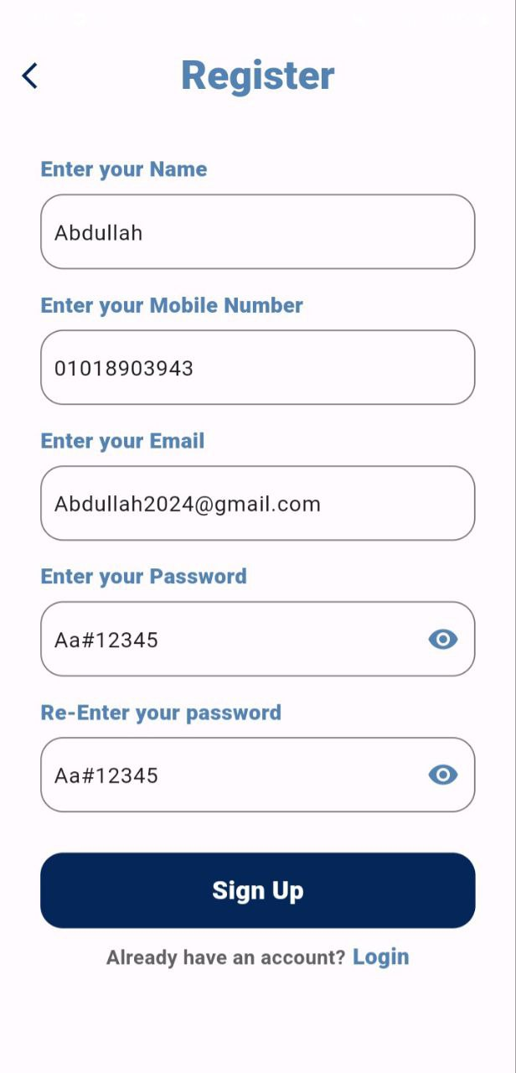 After Filling all the data Correctly like this

and click on Sign up

Wait until

Account Registration is complete

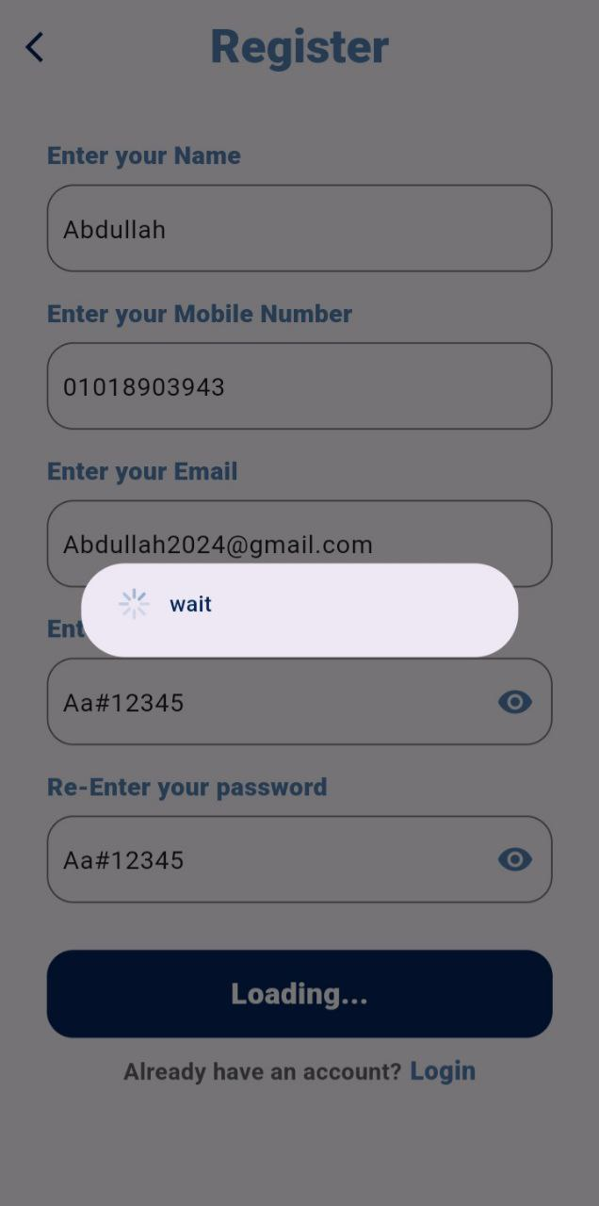

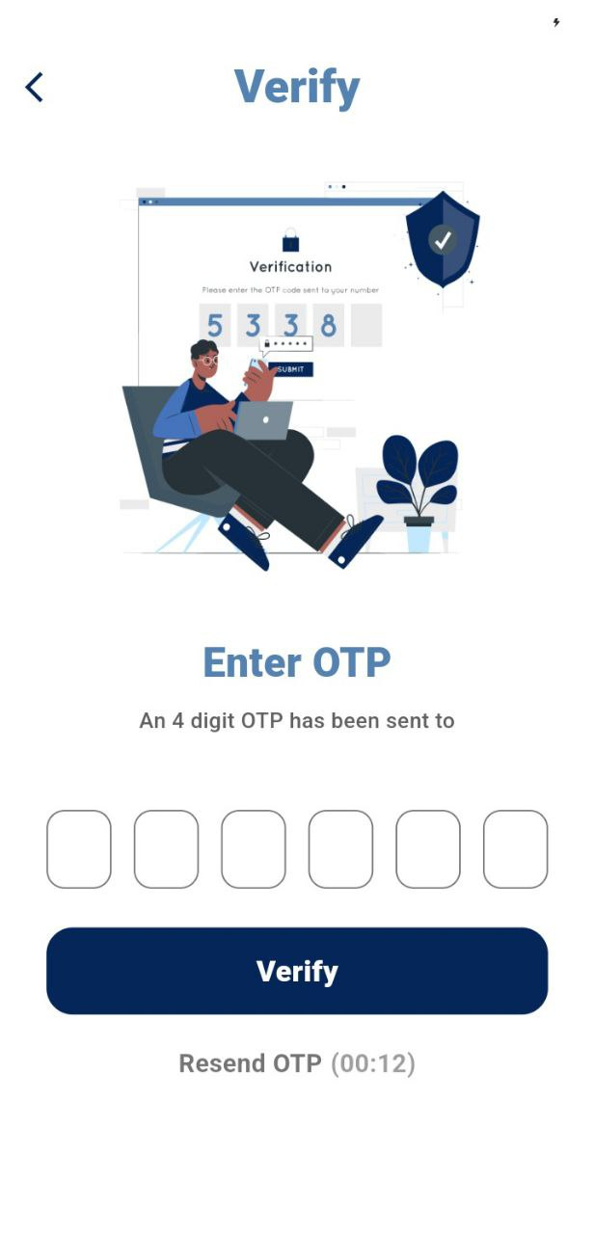

After that the Verify Screen

will appear.

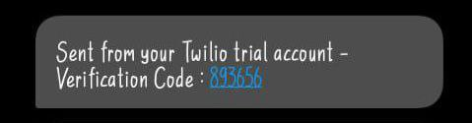The User receives Verification Code on their

Phone Number.

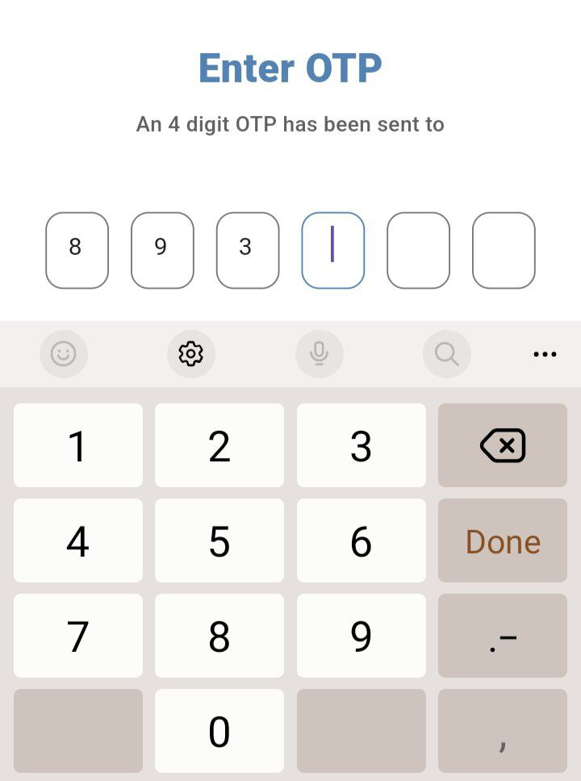

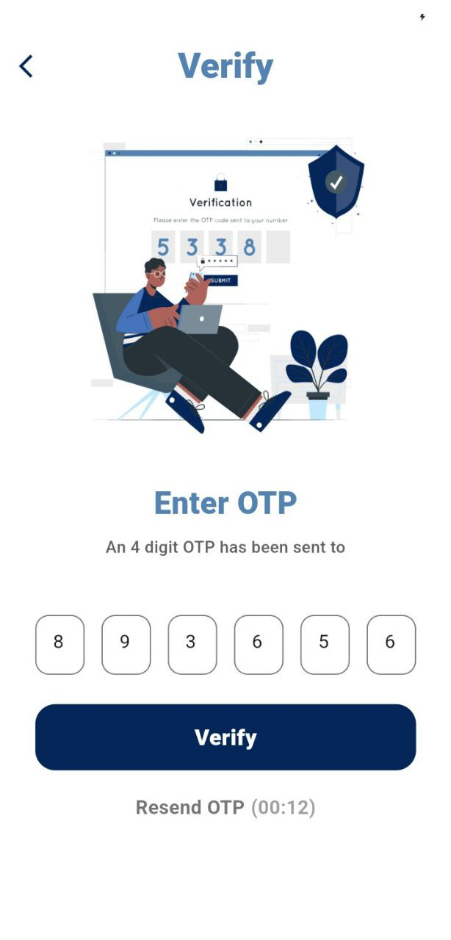Enter this Code

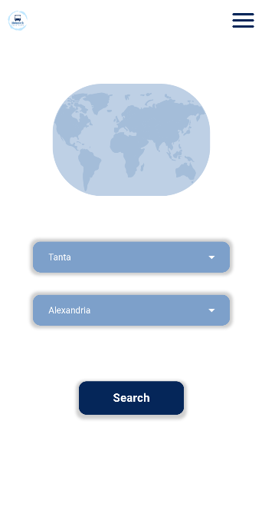

After Entering it

and Click On Verify

The Main Page will appear

* When the User enter the application for the Second time, they must Login the 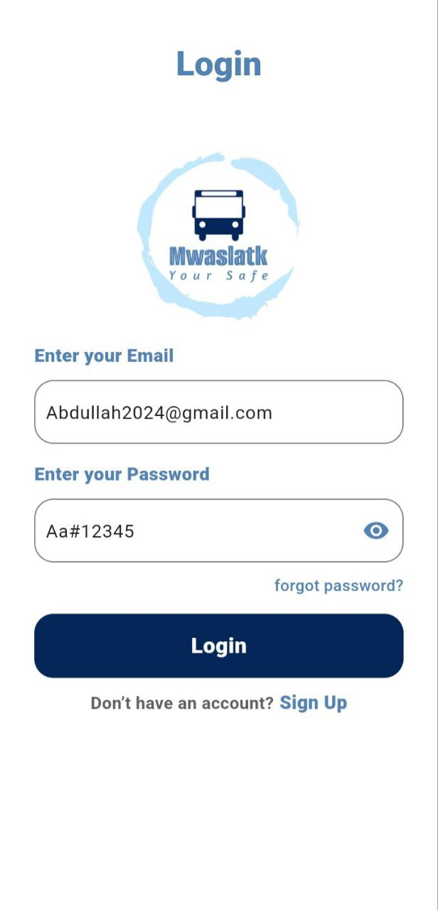app with their account.

After Click on Login

The Main Page will also appear

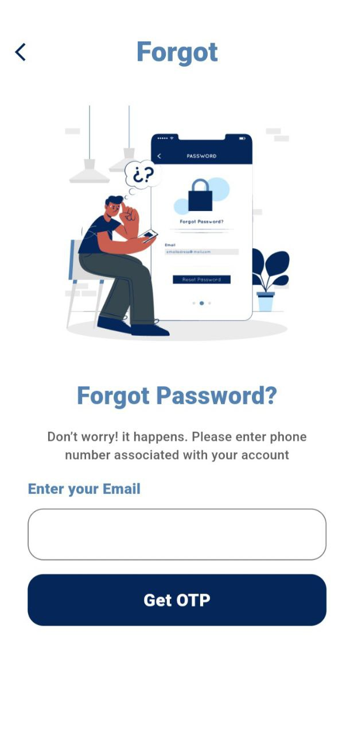

If the User forgot their Password, they can Click

On forgot Password

After this the forgot

screen will appear

The User must fill this field and enter

their account.

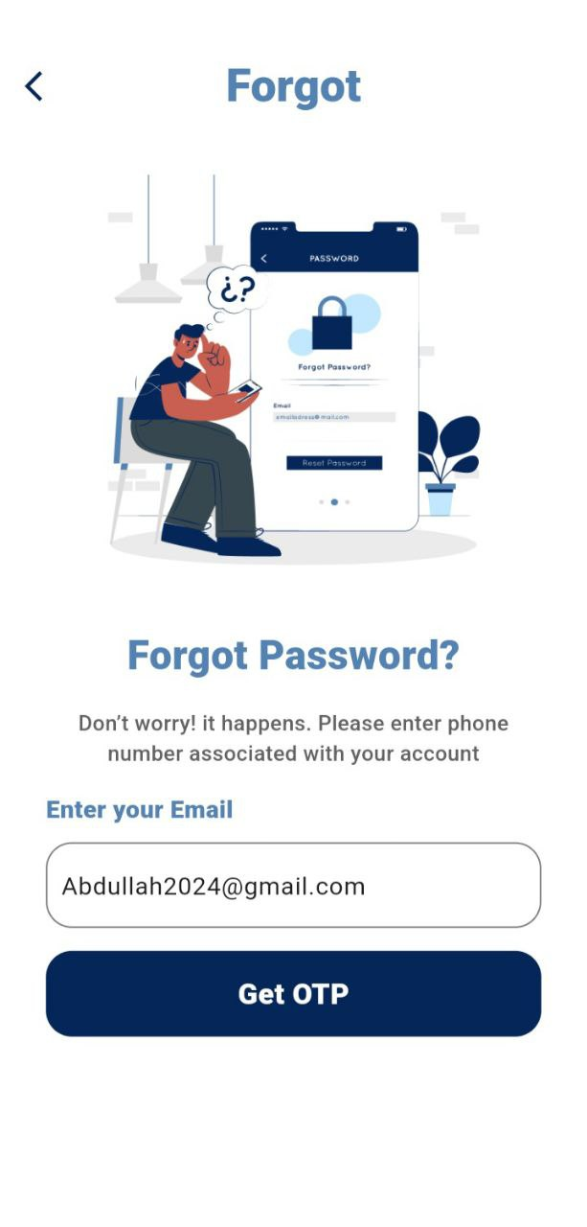 After Filling the field email Correctly like this

and click on Get OTP

Waiting until the account

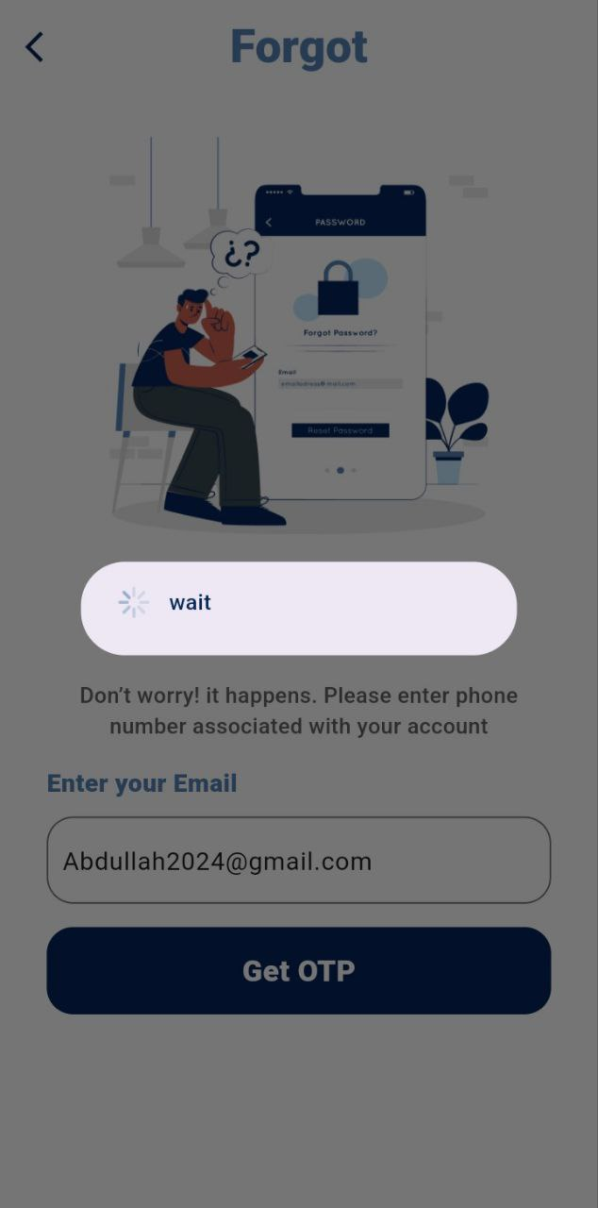 is determined

After that the Verify Screen

 will appear

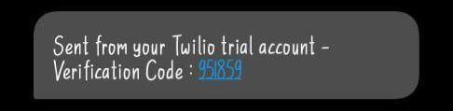The User receives Verification Code on their

Phone Number.

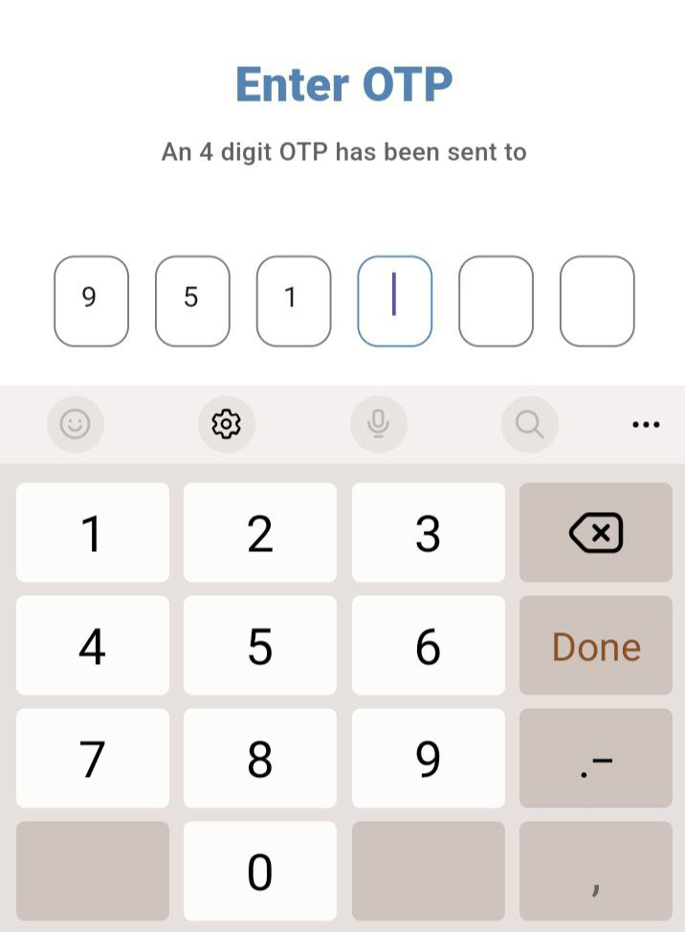

Enter this Code

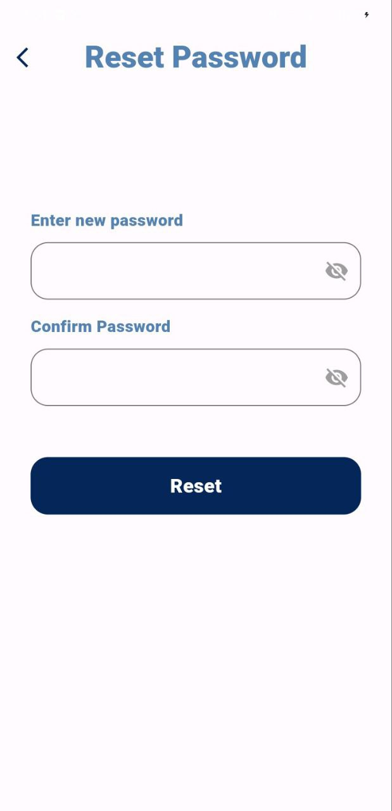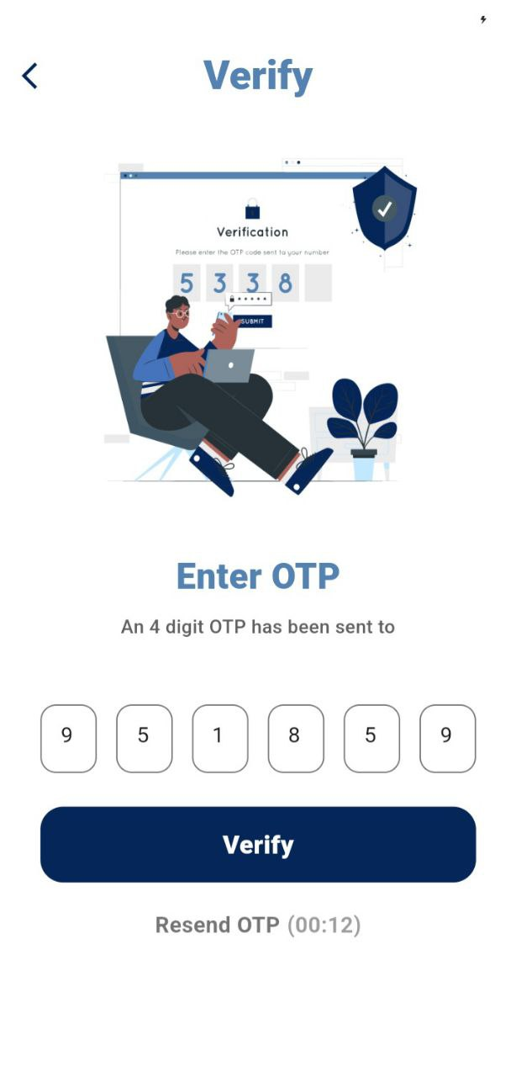

After Entering it

and Click On Verify

The Reset Password Screen

will appear.

* In the Reset Password Screen the User must enter their new Password and Confirm it

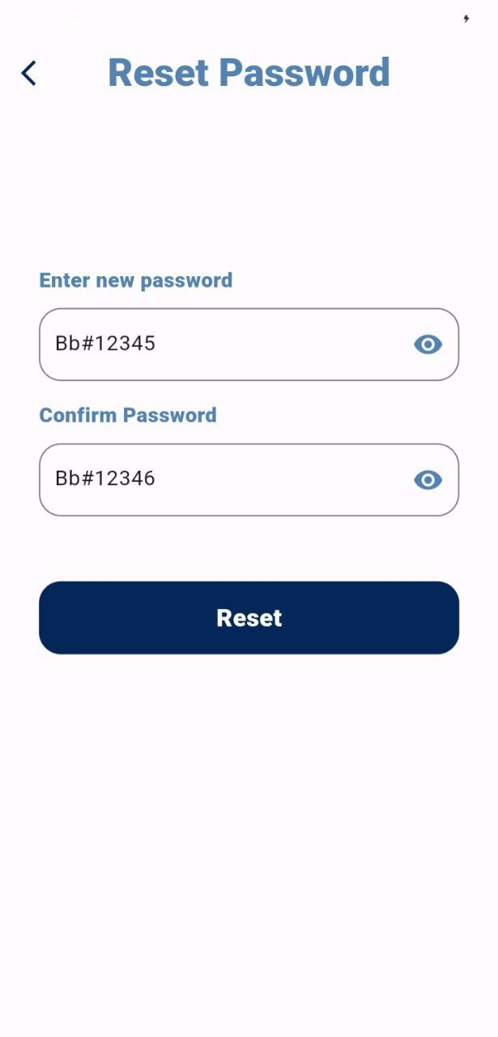

After Click on Reset

Waiting Until

the new Password saved

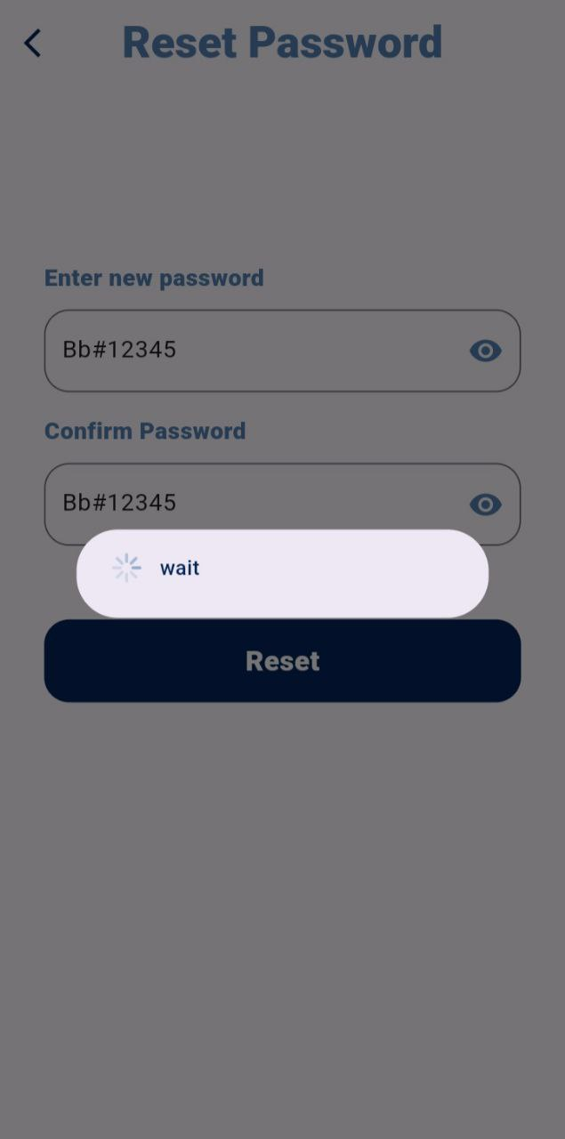

Through this icon the Appearance of

the Password could be Secure.

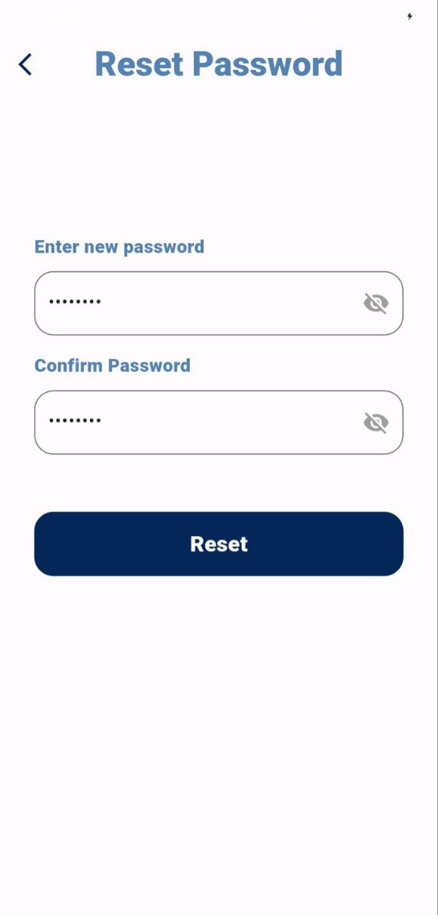

After that the Main Page

will appear.

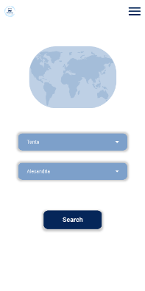

* If the User already have an Account but by mistake entered on Register Screen, they can go back to the Login Screen through ….

1. Click On this Icon to go to the previous screen

( Login Screen ).

Or

1. Click On Login to go to it

* After The User logs in once they can then enter the app

immediately because their Token is Stored.